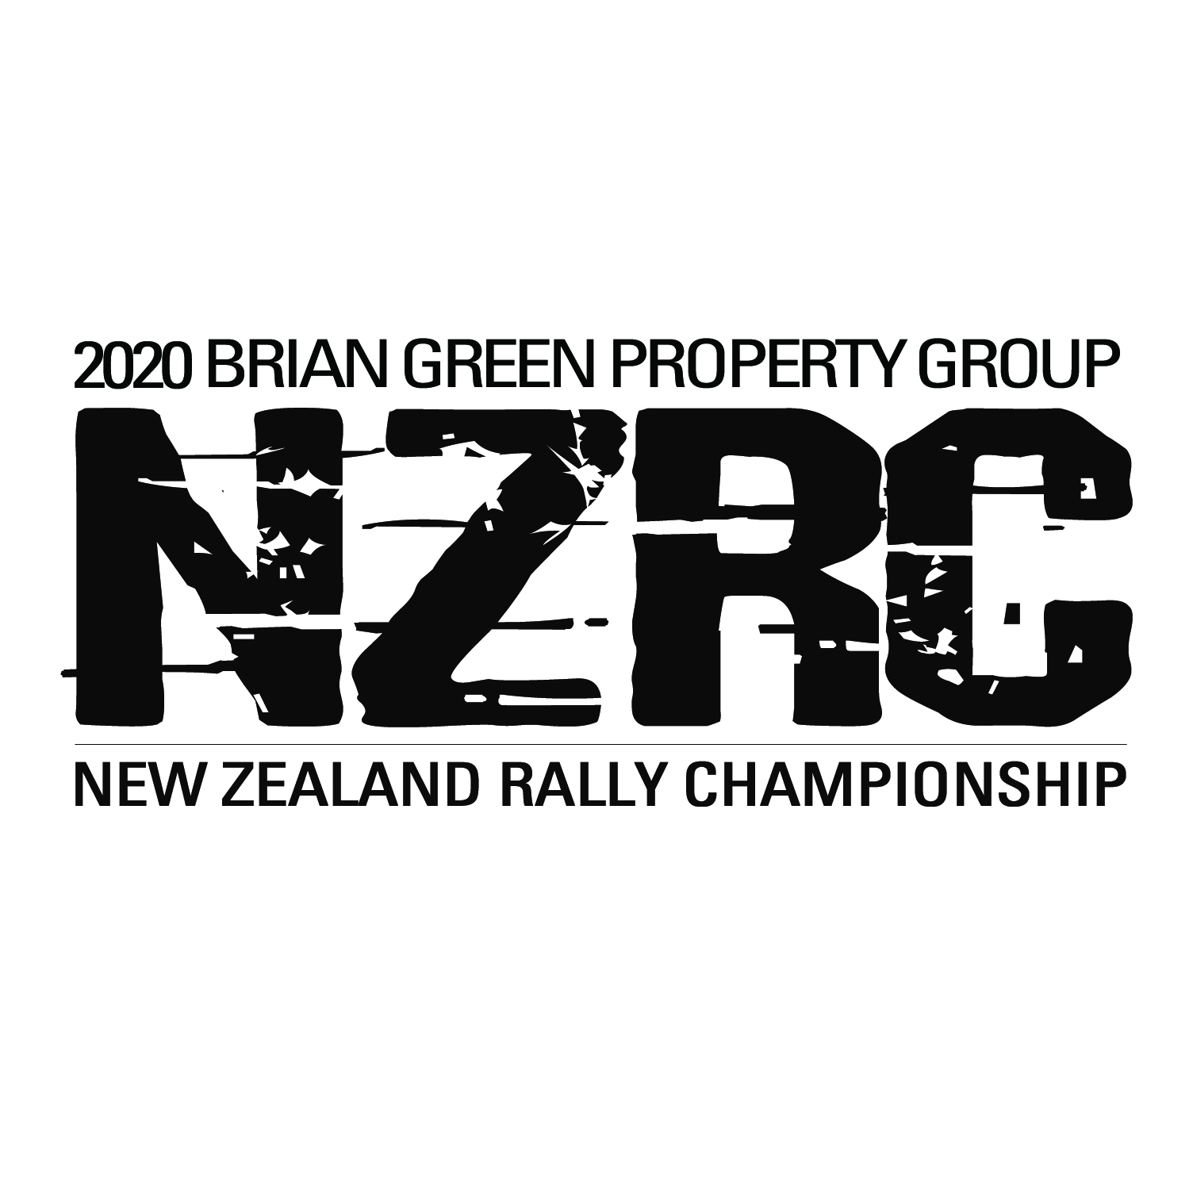
ORGANISERS USE ONLY
Group | Class
Entry Order  Received | Allocated  Comp No

New Zealand Rally Championship 2020 Registration Form

PLEASE RECORD THIS ENTRY FOR
A: Date of Meeting: N/A | B: Class Entered (Please circle): NZ1 NZ1A NZ2 NZ3 NZ4 NZ5A NZ5B NZ5C
C: Sponsors:
D: DRIVERS AND ENTRANT DETAILS
Please print in block letters |  | NO 1 DRIVER |  | NO 2 DRIVER |  |  | ENTRANT
Last Name
First Names
Date of Birth
Physical Address: Street / Town /

City
Postal Address for Event details (if different to No 1 driver’s address above) |  | Postcode:

Telephone Contacts: Home
Cellphone
Email address
Emergency Contact Name
Emergency Contact Phone
New Competitor Briefing:  If contested less than three rallies attendance is compulsory |  | Please tick here if you are required to attend the briefing: |  | Please tick here if you are required to attend the briefing:
Competition Licence No
Licence Grade
Expiry Date Of Comp. Licence
Financial Member Of
(Name Of Car Club & Expiry Date)
Civil Drivers Licence No
Currently is your NZ civil drivers licence disqualified? |  | Y / N |  | Y / N
If YES, then you must sign a declaration at Documentation as per NSC 43(2)(b)
Age Group  (Please Circle Applicable Group) |  | Under 19; 19-25; 26-35; 36-60; 61 Plus |  | Under 19; 19-25; 26-35; 36-60; 61 Plus
Foreign Participant on Non-MSNZ Licence |  | Y / N |  | Y / N
E: VEHICLE DETAILS
Vehicle Make: |  |  |  |  | Vehicle Model:
Engine Capacity (cc’s): |  | Year of Manufacture: |  |  | Colour of vehicle:
Registration No. |  | Log Book No.
F: PAST EXPERIENCE TO ASSIST WITH SEEDING
[Record here brief details of seeding and finish order in last three events entered]
Event: |  |  | Seeded: |  |  | Finish position:
Event: |  |  | Seeded: |  |  | Finish position:
Event: |  |  | Seeded |  |  | Finish position:
COMPETITOR PROFILE:

 | DRIVER | CO-DRIVER
Occupation

Favourite Rally Event and Why

Most Memorable Rallying Moment

Brief History of Rallying Activities (first started, when/how, successes, etc. Brief bullet points are fine)

JUNIOR DRIVER: (less than 25 years at 1 January 2020)
Are you eligible for this award? If so please confirm your date of birth | Date of Birth:  / /

CLASS:
Please check Championship Articles for details on Category Titles and complete the following as appropriate (Please tick appropriate box):
- Category 1: - 4WD
- category 1A - Group NZ 4WD
- Category 2: - FIA GROUP N 2WD, r1, r2 and r3
- Category 3: - oPEN cLASS 2WD
- Category 4: - HISTORIC Challenge Trophy
- Category 5: - NZ Rally challenge trophy – (A – 4WD B – 2WD C – GROUP A)
(please tick one)

Cat | Championship | Amount  (including GST)  Full season | Amount  (including GST)  Round by round | Due | TOTAL | Recd
1 & 1A | 4WD Championship | $850.00 | $250.00 | 23 Mar 19
2 | 2WD, R1, R2, R3 Championship | $550.00 | $200.00 | 23 Mar 19
3 | Open Class 2WD Championship | $550.00 | $200.00 | 23 Mar 19
4 | Historic Challenge Trophy | $550.00 | $200.00 | 23 Mar 19
5 | NZ Rally Challenge Trophy | $400.00 | $150.00 | 23 Mar 19
 |  | TOTAL

Enclosed are my registration fees for the Championship as indicated above.

- Please tick box if paying by direct credit
Bank: ASB Bank Ltd
Account Name: Rally of New Zealand Account Number: 12-3011-0203851-00
IBAN/Swift Code: ASBBNZ2A
  - Please make cheques payable to Rally New Zealand.
  - Please note that credit card details below authorise RNZ to process monies due as per the above due date.

Visa/Mastercard Details (circle) A fee of 3% will be added to all credit card transactions

Card Number    

Name of Card Holder_____________________________________ Expiry Date___________ Signature ______________________________

INDEMNITY:

1. Indemnity:
I have received the Supplementary Regulations and all other regulations or Articles as determined in the Appendices and Schedules of the current New Zealand Motorsport Manual for the event I am entering and agree to be bound by them and by the National Sporting Code of MotorSport New Zealand Inc.
In consideration of the acceptance of this entry and of my being permitted to take part in the Meeting or Events detailed, I agree not to pursue claims against and (severally) to hold harmless, indemnify and keep indemnified MotorSport New Zealand Inc, its members, associated or affiliated clubs and entities, rally and/or event organisers and promoters, the inviting club and entity (or entities), race circuit owners, providers and operators, owners and tenants of private property (including land, buildings and/or fixtures, fittings and chattels) traversed, or proximate to events, officials, fellow competitors, and the directors, officers, servants, representatives and agents of those entities (all together “the Indemnified Parties”) in relation to all losses, actions, expenses, costs, liabilities, claims and demands in respect of death, injury, loss or damage to persons or property of myself, and/or my team (including drivers, co-drivers, passengers, management and/or mechanics) whatsoever, caused or arising out of or in connection with this entry or taking part in the events to which this entry relates, notwithstanding that such death, injury, loss or damage may have been contributed to or caused by the negligence of any of the Indemnified Parties and/or by any other person. This provision confers a benefit on, and is intended to be enforceable by, each of the Indemnified Parties (in accordance with the Contracts (Privity) Act 1982).
2. Ability to Control a Vehicle Declaration by Driver:
I declare that should I at the time of any event this entry form relates to be suffering from any disability of any kind whether permanent or temporary which is likely to detrimentally affect my control of my automobile or my fitness to drive, I will not participate.
3. Vehicle Conformance with Schedule A/AA Declaration by Driver:
I declare the vehicle detailed on this entry form complies with the vehicle safety items set out below (as applicable) and will be presented on request to an appointed Scrutineer or Technical Officer complying at all times with the safety and eligibility requirements detailed in the National Sporting Code and its Appendices and Schedules.
Critical Safety | Non-Critical Safety |  | Non Safety
- Helmet  - Head & Neck Restraint  - Protective Clothing  - Safety Harness  - Window Net(s)  - Roll Bar / Safety Cage  - Seat(s) and Mounts  - Fire Extinguisher  - Wheels and Tyres  - Brake System  - Steering & Suspension Systems  - Fuel Tank(s) / Fillers / Lines  - Fuel / Oil / Brake Line Protection  - First Aid Kit / Safety Triangle | - Engine and Transmission  Mounts  - Flexible Fluid Lines & Hoses  - Throttle Return (Failsafe)  - Engine Starter Operation  - Reverse Gear Operation  - Exhaust System  - Oil Catch Tank(s)  - Electrical Wiring  - Ignition / Circuit Breaker  - Battery  - Lighting Systems  - Brake Lights  - Rear Lights | - Bodyshell / Chassis Condition  - Exterior Appearance  - Panels / Covers  - Doors  - Windows  - Wipers and Demisting  - Rear Vision Mirrors  - Aerofoils & Spoilers  - Cockpit Construction / Fittings  - Bulkheads  - Tow Eyes  - Mudflaps  - Tow Rope  - Auxiliary Lights | - Ballast (Security)  - Competition Numbers  - Registration & WOF Labels  - LVV / MSNZ Authority Card  - LVV Plate  - Optional Equipment  - Restrictor Fitment (36mm ID)
I acknowledge that where any breach of the Safety Schedule is found during a Scrutineering Audit I will be subject to penalties under the National Sporting Code and my signature below indicates my acceptance of this undertaking.
4. Consent:
I consent to the details contained on this form being held by Rally of New Zealand Ltd, and/or the Inviting Clubs for the purpose of the promotion and benefit of the Rally Event(s) concerned, and Motorsport in general. I acknowledge my right to access and correction of this information. This consent is given in accordance with the Privacy Act 1993.
I also authorise the medical providers of the event to disclose medical information relevant to injury or illness sustained during the above mentioned event to MotorSport NZ and its officials.

Signature of No. 1 Driver: Date: / /

Signature of No. 2 Driver: Date: / /

[For entry to be valid please ensure that all signatures are completed prior to posting]

FOR ENTRY TO BE CORRECT, PLEASE ENSURE SIGNATURES ARE COMPLETED PRIOR TO POSTING

Please return completed form at least two (2) weeks prior to the first Round entered:

EMAIL info@rallynz.org.nz
OR
POST TO Rally New Zealand, PO Box 62021, Sylvia Park, Auckland 1644

TEAM REGISTRATION FORM

(Please print clearly in BLOCK CAPITALS)

Team Name (if applicable):
Team Captain Name:

 | Driver Name | Co-Driver Name | Category / Class
1
2

A maximum of two (2) competitors are eligible per team

I confirm that the Team members nominated above are not registered for another team in the Championship.

Signature of
Team Captain: Date: / /

Please return completed form at least two (2) weeks prior to the first Round entered:

POST TO: Rally New Zealand, PO Box 62021, Sylvia Park, Auckland 1644
OR
EMAIL: info@rallynz.org.nz

TEAM MEDIA PARTNER REGISTRATION FORM
If your team will be using a media to cover your event and season, please detail the company and contact details below to register them with the NZRC. Your intended use of the media may be required to be approved by the promotors if it is in direct competition with any NZRC promotion or its partners promotions.
(Please print clearly in BLOCK CAPITALS)
Media Company or Individuals Name
MSNZ accredited? Yes No Accreditation Number:

Contact Person
Contact Phone # | Email Address:
Are the media / photography / moving pictures intended for commercial use? Y / N

Please let us know the intended use of the media / photography / moving images:

What platforms will the media used on?

PLEASE TICK:

Yes, I certify that I agree to the terms and conditions of this media registration

By submitting and signing this form, you agree with the terms and conditions set by the promotors of the New Zealand Rally Championship (NZRC), Rally New Zealand for on event media.

We acknowledge that:
- There are risks associated with media attending the NZRC events and include the risk that I/our media team may suffer harm as a result of:
  - motor vehicles (or parts of them) colliding with other motor vehicles, persons, structures or other property;
  - acts of violence and other harmful acts (whether intentional or inadvertent) committed by persons attending or participating in the event.
- Motorsport is dangerous and accidents causing harm and death can and do happen and may happen to me.
- No official timing, results or other data including photographs, vision or sound recordings relating to the events may be reproduced, stored in a retrieval system or transmitted in any form or by any electronic, mechanical, photocopying, recording, or broadcasting means or otherwise without the prior express written permission of Rally New Zealand / NZRC except for reproduction by local, national or international press in regular publications on sale to the public or accessible on their corresponding authorised internet sites.
- No person shall make or use radio broadcasts and/or take moving picture images, livestreams of the events for commercial purposes, without the prior express written permission of the Rally New Zealand / NZRC
- We are accredited with MSNZ and acknowledge that Rally New Zealand / NZRC are using my details for on event identification and ongoing event communication.
- We agree that the waiver and indemnity set out above shall bind my personal representatives and assignees, and my trustees, executors or administrators.
- We always agree to wear MSNZ accredited high-visibility apparel while we are at a Rally New Zealand / NZRC events.
- We agree to promptly comply with all directions and instructions given to me by any officer or official having or appearing to have authority to act in respect of a Rally New Zealand / NZRC event.

Copyright
In consideration of being granted access to the Rally New Zealand / NZRC events for media purposes to support a competing NZRC team, we acknowledge that, while we are permitted to use all down-loadable words and pictures available on the Rally New Zealand / NZRC websites for editorial purposes, I agree that copyright in all such material is exclusively owned by the Rally New Zealand / NZRC and that I may not, without prior consent, use any such content for any commercial purpose (such as printed advertisements, on-line advertising or any other non-editorial purpose). I further agree to credit NZRC in any print or on-line news content for any images down-loaded and used.

In consideration of being at a Rally New Zealand / NZRC sanctioned event (a "restricted area"), we irrevocably waive all and any rights we may have against Rally New Zealand / NZRC or any of its officers, employees, agents or contractors, howsoever arising, in respect of any cost, claim, loss, liability, damages or injury suffered or incurred by us while at an Rally New Zealand / NZRC event. We agree to irrevocably indemnify and hold harmless Rally New Zealand / NZRC and its officers, employees, agents or contractors from and against all and any cost, claims, loss, liability or damages suffered or incurred by Rally New Zealand / NZRC or any of its officers, employees, agents or contractors directly or indirectly or as a result or consequence of any claim made or proceedings threatened or commenced by any person, firm, or other entity whomsoever or whatsoever arising out of my access to an Rally New Zealand / NZRC event, whether resulting from any act or omission on the part of Rally New Zealand / NZRC or not.

Signature of Entrant: Date: / /

